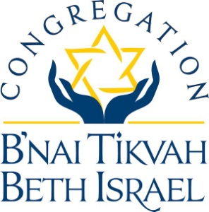

***Sisterhood Rosh Hashanah Challah Sale***

***(2024 – 5785)***

Orders can be placed for delicious challahs from Kosher Mart Foods through **Thursday, September, 12 2024**. Checks should be made out to **CBTBI SISTERHOOD** and left in the Sisterhood mailbox in the office or mailed to

Allison Harris

168 Chancellor Drive

Deptford, NJ 08096

[aharris888@comcast.net](mailto:aharris888@comcast.net)

609-506-5687

Challahs will be available for pick up at CBTBI on **SUNDAY,**

**September 29, 2024 from 11:00 am to 1:00 pm.**  **If you cannot pick up at that time, please contact Allison to make other arrangements.**

--------------------------------------------------------------------------------------------------

Please submit orders no later than **Thursday, September 12th, 2024.**

Name: ________________________________ Phone Number: __________________

________ Plain (15oz round) X $5.50 each $ _________

________ Raisin (15 oz round) X $6.00 each $ _________

________ Gluten Free (21 oz - NOT round/pre-sliced) X $6.50 each $ _________

**\*\* CBTBI is running low on challahs for Friday night and Saturday onegs. If you would like to purchase additional plain challahs and donate them, your contribution would be greatly appreciated. Thank you.**

**I would like to donate ______ plain challah (s) for onegs X $5.50 each** $ _________

Total Amount Enclosed: $ _________